**The 21st Century Physics Classroom: How Research Informs Classroom Design.**

*Chris Whittaker and Elizabeth S. Charles – Dawson College, Montreal, QC.*

Traditional post-secondary classrooms are designed to facilitate the transfer of information from expert to novice: there’s a place at the front for the teacher to talk, and there are places for the students to listen – usually in front-facing rows of desks.

Modern classrooms, however, can – and should – do much more.

Instead of being passive, teacher-centred spaces, classrooms should be designed with student-centred, active-learning strategies in mind. Decades of physics education research has shown that active-learning instruction can significantly improve meaningful learning in comparison to traditional lecture-based instruction in college-level physics courses (Meltzer and Thornton, 2012).

So, what does a modern student-centred active-learning classroom look like? How can classroom design help maximize active-learning strategies and how can classrooms make the most of the affordances for learning that come with modern technology?

**How Do We Learn? The constructivist model**

Learning is an active, contextualized process that builds on prior knowledge (Bransford, Brown & Cocking, 1999). It is done through social interactions and is mediated by tools (Vygotsky, 1978). Learning is therefore not simply a matter of transferring knowledge from expert to novice – it is a process of constructing ones own conceptual framework. To learn physics is to actively engage in using the conceptual tools and ways of thinking that define the field of physics. Importantly, effective learning occurs when students are properly situated in their zone of proximal development, that is, when they are faced with challenging learning activities that they can master with the supports available to them (Vygotsky, 1978).

**How Should We Teach?**

Teaching should be about providing opportunities and support for meaningful learning. Based on an awareness and understanding of prior knowledge – and in the case of physics, an understanding of deeply rooted misconceptions – class-time should be spent on opportunities that allow the student to explore his/her zone of proximal development. In order to do that, the teacher needs to plan an effective series of learning activities. This plan is referred to as a “script” (Kollar, Fischer & Slotta, 2007) and it is important that both the classroom design and the technology in it work together to maximize the teacher’s ability to carry out scripts with a variety of activities – such as mini-lectures, peer-instruction, interactive simulations (like PhETs), group work, problem solving, jigsaw activities, etc.

It is equally important that the classroom provide the teacher with the tools to dynamically control how a script is carried out in the class – something that is called “orchestration” (Dillenbourg & Jermann, 2013). In order to maximize learning opportunities in the orchestration of an effective active learning script a teacher needs to manage many things, including collaborative learning strategies, student and group self-regulation, along with metacognitive processes. Both the classroom design and the technology in the classroom can help with orchestration.

Lastly, an important piece of the scripting and orchestration process – and hence the design of a classroom and its capacities – involves the following processes (Collins et al., 1991):

* *modeling* – teachers should engage in the explicit articulation of expert thinking and the performance of expert practices within the domain;
* *coaching* – teachers (and knowledgeable peers) should observe and help students as they work by giving guidance and support;
* *scaffolding* – the tasks and tools provided to students should support their construction of knowledge in a way that allows for the removal of those supports once their understanding has solidified;
* *articulation* – students should have ample opportunities to articulate their knowledge and reasoning while practicing problem solving strategies;
* *reflection* – students should be engaged in metacognitive activities at the individual, group, and classroom levels;

**From Absorbing to Constructing: A new design paradigm.**

If students construct knowledge through interactions with each other and the subject material, and if both the teacher and student roles in the classroom expand, what elements are important in a new paradigm for classroom design?

* The central focus of the classroom should not be on the teacher but on the social interactions through which knowledge is best constructed, including peer-to-peer interactions and novice-to-expert interactions.
* The most powerful tools possible for creating meaningful and lasting artefacts of knowledge should be put in the hands of the students (and not just the teacher).
* The classroom design must facilitate the teacher’s ability to interact with and assess students and their work, and it should provide the teacher with easy to use yet powerful orchestration tools.

**Some Examples.**

Over the last two decades, new classroom designs have emerged that meet many of the design features listed above. Among the most popular are the SCALE-UP classrooms (Student-Centered Active Learning Environment with Upside-down Pedagogies) that were pioneered at North Carolina State University. Since the early 1990’s these classrooms have steadily grown in popularity, as has the evidence of their effectiveness (Beichner et al., 2007; Brooker et al., 1013; Dori and Belcher 2005). This evidence, including preliminary results from studies on the newer classrooms at Dawson College as outlined below, show significant increases in conceptual understanding, improved attitudes, successful problem solving, and higher success rates, particularly for females and minorities.

There are now more than 150 such classrooms across North America – including the much talked about spin-off TEAL classrooms (Technology Enabled Active Learning) at M.I.T. as well classrooms at McGill, UBC, McMaster and Simon Fraser University here in Canada.

SCALE-UP (http://scaleup.ncsu.edu) classrooms feature round tables where students work collaboratively in groups. In most cases tables seat nine, which means that it’s easy to subdivide students into three groups of three at each table. Around the walls of these classrooms are a mix of whiteboards and screens that project the contents of student or teacher computers to individual screens or to the entire room. Importantly, the teacher is no longer the centre of attention but rather the groups and their work that are. SCALE-UP classrooms typically seat 50 to 130 students. In some cases, such as the TEAL classrooms at M.I.T. (http://icampus.mit.edu/projects/teal/), the technology also allows for a collaborative, hands-on environment where students can carry out desktop experiments and engage in interactive learning activities that use projection screens.

A newer variant of Active Learning Classrooms has recently been developed at Dawson College in Montreal by the authors. In our case, we sought to use the lessons of active learning classroom research to enhance collaborative group work in smaller classrooms (30-40 students) by integrating interactive touch-screen technologies into each student group. Instead of using a combination of whiteboards and projectors, Dawson’s Technology Rich Active Learning Classrooms (DTR-ALC) feature SMART Boards (<http://smarttech.com/smartboard>) for each student group. SMART Boards – both in terms of the technology and the software suite that comes with them - offer unique affordances when it comes to collaborative group work and in particular, they offer powerful opportunities for the creation, manipulation and distribution of shared artefacts and the orchestration of class activities.

In order to seamlessly integrate SMART Boards into the groups and in order to facilitate the exchange between all students sitting at a table, we had to re-think the table itself. Instead of a large round table with lots of space and computer screens in the middle, we decided to make the tables smaller and shaped like an oval with one end “pinched”. We also removed any obstacles on the tabletop and we placed the SMART Board at the wide end of the table. This design has many advantages:

* It brings every student within reach of any other students in the group – no one is so far away that they can’t talk with any other group member or slide a piece of paper across to them.
* The table shape reinforces the importance of the SMART Board and invites students to integrate it into their activities without detracting from the group itself.
* The “pinched” oval shape allows for greater room between the tables which facilitates circulation and interactions.
* A local area network coupled with SMART Classroom Suite™ software allows for the creation of lasting, dynamic learning artefacts, along with the effective orchestration and control of the classroom.

Unfortunately, money doesn’t grow on trees and the investment required for technology-rich active learning classrooms is significant. Having said that, as interactive technologies continue to develop, these costs will only decrease making such learning environments more and more affordable. What’s more, low-tech variants of the designs outlined here may provide ways to get much of the learning advantages of these classrooms at a fraction of the cost. At Dawson college, such classrooms are in the works and it is anticipated that when used in collaboration with the high-tech rooms through a flexible scheduling arrangement that the benefit-to-cost ratio will be maximized. In any case, it is essential that research continue so that we can identify successful pedagogical strategies and engage in a meaningful cost-benefits analysis.

**One Last Thing**

It is important to note that classroom design is not as important as pedagogy (Charles et al. 2012). Active learning can be done in any classroom, but in a classroom that is specifically designed for it, there are richer opportunities to make the most of active learning strategies. The downside is that teaching in an active learning classroom effectively can be very challenging. It is therefore not enough to build new classrooms without developing the expertise to use them properly. At Dawson College, and at most of the other institutions we collaborate with, the development of expertise is done through a vibrant community of practice and we incorporate research into our community of practice in a very important way.

Photos:

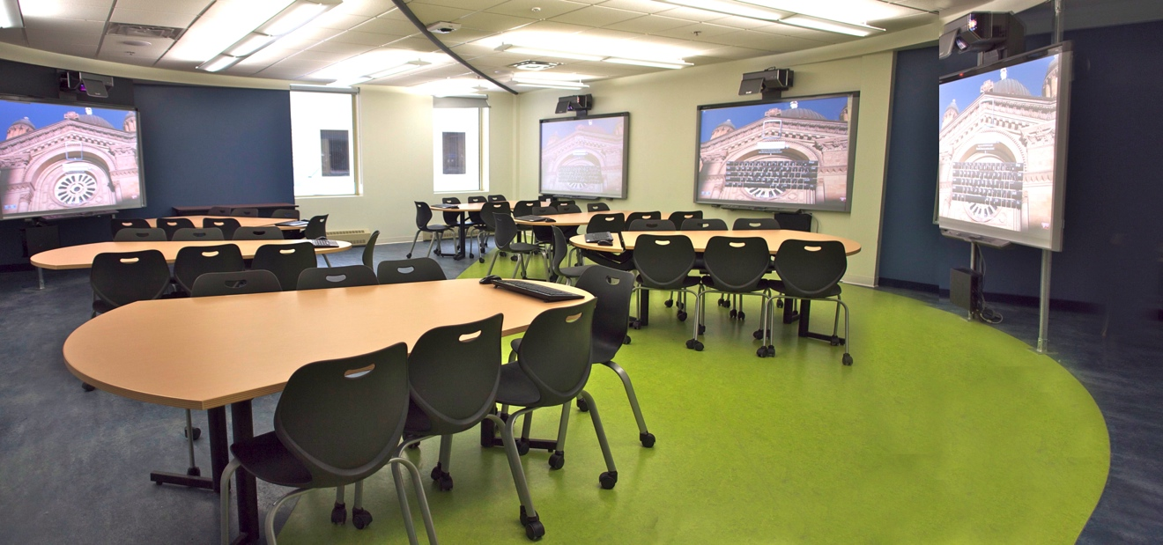

Figure 1. The Dawson Technology Rich Active Learning Classroom (DTR-ALC).

**References:**

Dewey, J. 1915. *The School and Society.* Chicago, IL: University of Chicago Press.

Greeno, J. G. (1998). The situativity of knowing, learning, and research. *American Psychologist, 53*(1), 5-26.

Bransford, J.D., Brown, A.L., & Cocking, R.R. (Eds.) (1999). *How People Learn: Brain, Mind, Experience, and School*. Washington, DC: National Academy Press.

Vygotsky, L.S., 1978. *Mind in Society: The Development of the Higher Psychological Processes*. Cambridge, MA: The Harvard University Press. (Originally published 1930, New York: Oxford University Press.)

Beichner, R.J., Saul, J.M., Abbott, D.S., Morse, J.J., Deardorff, D.L., Allain, R.J., Bonham, S.W., Dancy, M.H., & Risley, J.S. 2007. The Student-Centered Activities for Large Enrollment Undergraduate Programs (SCALE-UP) project. In E. Redish (Ed.) *Research-based reform of introductory physics*. Available online by searching PER Central at www.compadre.org/per

Mazur, E. (1997). *Peer instruction: a user's manual*. Upper Saddle River, N.J.: Prentice Hall.

Charles, E., Lasry, N., & Whittaker, C. (2012). *Redesigning Classroom Learning Spaces: When technology meets pedagogy and when they clash*. van Aalst, J., Thompson, K., Jacobson, M. J., & Reimann, P. (Eds.) (2012). *The Future of Learning: Proceedings of the 10th International Conference of* *the Learning Sciences (ICLS 2012) – Volume 2. pp. 207-211.* International Society of the Learning Sciences: Sydney, NSW, Australia.

Brooker, R., Matthes, D. Wright, R., Wassenburg, D., Wick, S., Couch B. (2013). SCALE-UP in a Large Introductory Biology Course. In Tricia A. Ferrett. and David R. Geelan. and Whitney M. Schlegel. and Joanne L. Stewart. and Mary Taylor Huber. and Pat Hutchings (Editors). *Connected Science: Strategies for Integrative Learning in College.* Bloomington: Indiana University Press. *Project MUSE*. Web. 15 Sep. 2013. <http://muse.jhu.edu/>.

Dillenbourg, P., & Jermann, P. (pre-publication draft 2013). Technology for classroom orchestration. M. S Khine and I. M. Saleh (Eds) *New Science of Learning: Cognition, Computers and Collaboration in Education.* Springer*.*

Dori, Y. & Belcher, J. (2004). How does technology-enabled active learning affect undergraduate students understanding of electromagnetism concepts? *The Journal of the Learning Sciences*, *14*(2).

# Kollar, I., Fischer, F., & Slotta, J.D. (2007). Internal and external scripts in computer-supported collaborative inquiry learning. *Learning and Instruction*, 17(6), 708-721.